IDEATION PHASE: BRAINSTORM & IDEA PRIORITIZATION
Project Name: AI Study Buddy | Innovation Framework Template

Date | 28-9-26
Project Name | AI Study Buddy
Team Leader | Shaheere Bhanu S
Team Members | Jeevitha K, Pooja N, Shobana Patra G

Team id:SWTID-2026-5609

Brainstorm & Idea Prioritization Template Description:
Brainstorming provides a free and open environment that encourages everyone within a team to participate in the creative thinking process that leads to problem solving. Prioritizing volume over value, out-of-the-box ideas are welcome and built upon, and all participants are encouraged to collaborate, helping each other develop a rich amount of creative solutions.
This document captures the structured ideation, feature categorization, and impact-versus-feasibility prioritization for the AI Study Buddy project led by Shaheere Banu and her team.

Step 1: Team Gathering, Collaboration & Problem Statement
Define your problem statement: What problem are you trying to solve? Frame your problem as a How Might We statement. This will be the focus of your brainstorm.
Problem Statement: How might we create an intelligent, personalized AI Study Buddy that helps students manage study schedules, summarize complex materials, and practice active recall efficiently?
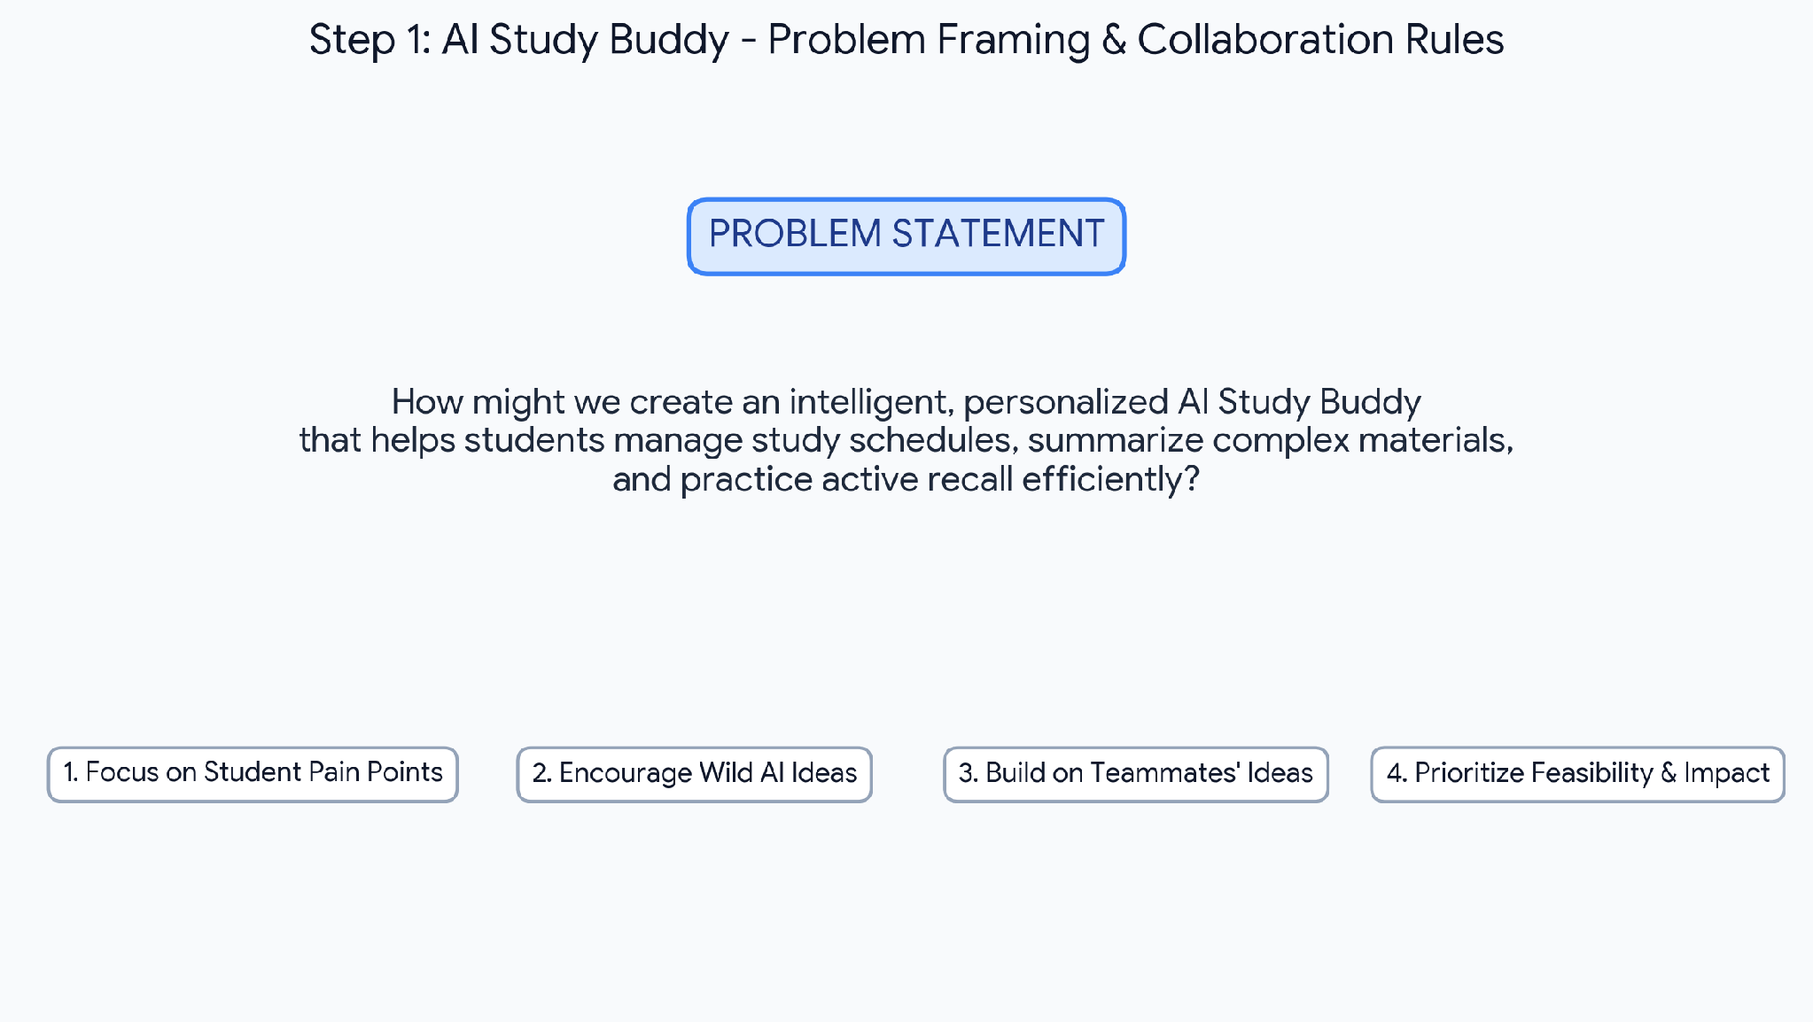
Figure 1: Step-1 Collaboration Setup, Key Rules & Problem Statement

Step 2: Brainstorm, Idea Listing & Grouping
Write down any ideas that come to mind that address your problem statement. Take turns sharing your ideas while clustering similar or related notes as you go. In the last 10 minutes, give each cluster a sentence-like label.
Team Member | Brainstormed Sticky Note Contributions for AI Study Buddy
Shaheere Banu (Team Leader) | • Automated Smart Study Planner & Dynamic Timetable  • Exam Countdown & Adaptive Revision Reminder  • Spaced Repetition Scheduling Algorithm
Jeevitha K | • Instant PDF & Lecture Notes Summarizer  • Automatic Mind Map & Concept Diagram Generator  • Key Terminology & Formula Sheet Extractor
Pooja N | • Interactive AI Flashcards with Active Recall  • Dynamic Quiz Generator from Study Material  • Voice-enabled Oral Practice Tutor
Shobana Patra G | • Study Streak Gamification & Digital Badges  • Peer Study Group Matcher & Collaborative Rooms  • Focus Mode & Distraction Blocker Timer

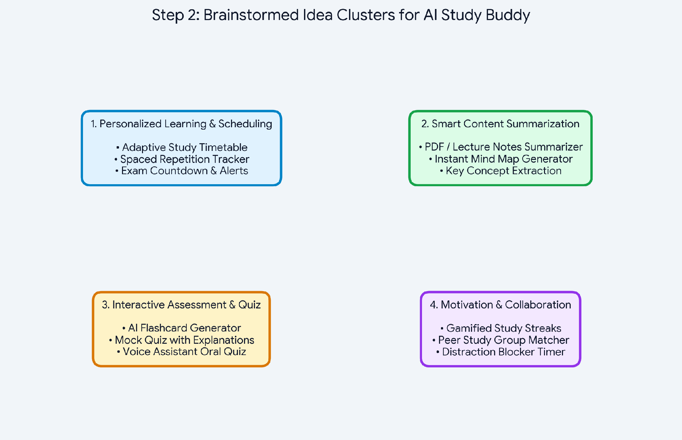
Figure 2: Step-2 Categorized Brainstorming Sticky Note Clusters

Step 3: Idea Prioritization
Prioritize: Your team should all be on the same page about what's important moving forward. Place your ideas on this grid to determine which ideas are important and which are feasible.
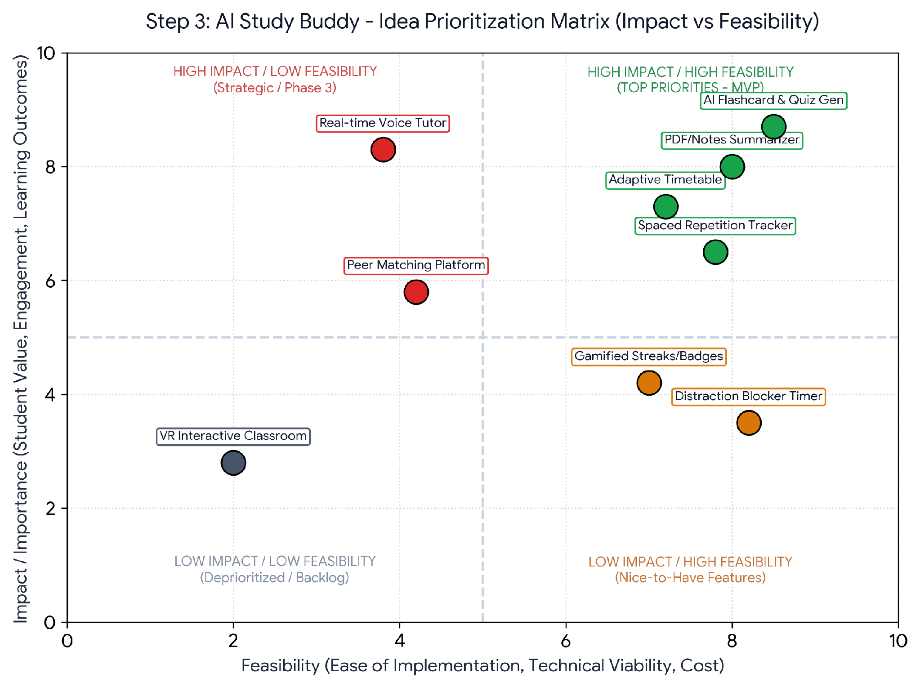
Figure 3: Step-3 Importance vs. Feasibility Prioritization Grid

Feature Prioritization Breakdown Table:
Priority Quadrant | Selected Features | Strategic Justification
High Impact / High Feasibility  (Top Priority / MVP Core) | • AI Flashcard & Quiz Generator  • PDF/Notes Smart Summarizer  • Adaptive Study Timetable | Directly addresses core learning issues, delivers immediate student value, highly feasible with standard LLM technology.
High Impact / Medium Feasibility  (Phase 2 Extensions) | • Spaced Repetition Tracker  • Real-Time Voice Oral Tutor | Proven learning efficacy; requires audio API processing and algorithmic recommendation modeling.
Low Impact / High Feasibility  (Nice-to-Have) | • Gamified Streaks & Badges  • Focus Mode / Distraction Blocker | Simple to implement and boosts engagement, but secondary to fundamental core learning tools.
High Complexity / Low Feasibility  (Future Backlog) | • VR Interactive Classroom  • Peer Matching Social Platform | High infrastructure complexity and network requirements; deferred to future iterations.

